**DAILY ONLINE ACTIVITIES SUMMARY**

|  |  |  |  |  |  |  |  |  |
| --- | --- | --- | --- | --- | --- | --- | --- | --- |
| **Date:** | **18/05/2020** | | | | | **Name:** | **NAIPUNYA VINOD NAIK** | |
| **Sem & Sec** | **IV SEM A SEC** | | | | | **USN:** | **4AL18CS050** | |
| **Online Test Summary** | | | | | | | | |
| **Subject** | | **COMPLEX ANALYSIS, PROBABILITY AND STATISTICAL METHODS** | | | | | | |
| **Max. Marks** | | **30** | | **Score** | | | **11** | |
| **Certification Course Summary** | | | | | | | | |
| **Course** | **INTRODUCTION TO HADOOP** | | | | | | | |
| **Certificate Provider** | | | **GREAT LEARNING ACADEMY** | | **Duration** | | | **5.5 HRS** |
| **Coding Challenges** | | | | | | | | |
| **Problem Statement:**  Top of Form  Bottom of Form   |  | | --- | | 1.Using methods charAt() & length() of String class, write a program to print the frequency of each character in a string. “Hello friend”  Output should be -: 1 d: 1 e: 2 f: 1 | | | | | | | | | |
| **Status: EXECUTED** | | | | | | | | |
| **Uploaded the report in Github** | | | | | **YES** | | | |
| **If yes Repository name** | | | | |  | | | |
| **Uploaded the report in slack** | | | | | **YES** | | | |

Online Test Details: (Attach the snapshot and briefly write the report for the same).

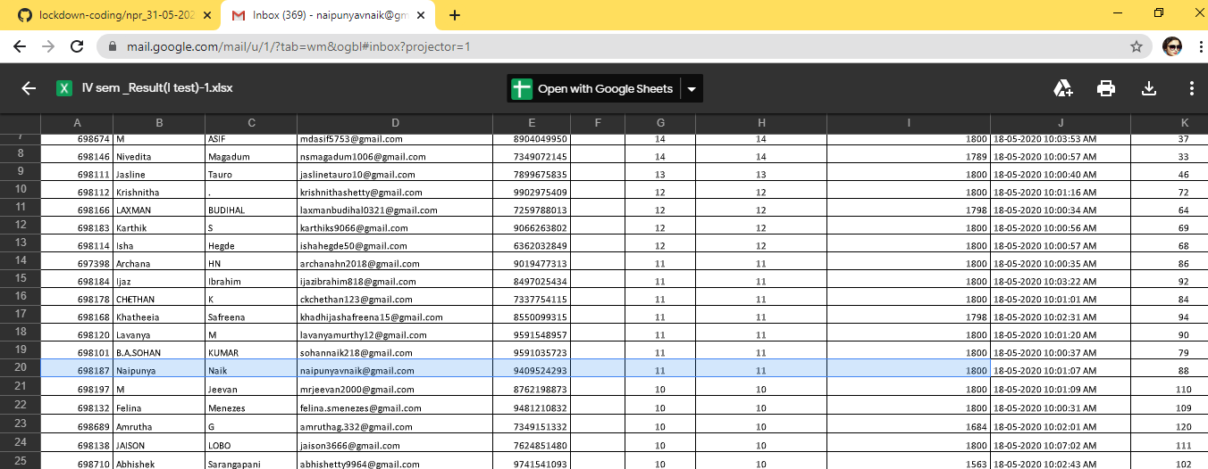

* THE 1ST I.A TEST OF COMPLEX ANALYSIS , PROBABILITY AND STATISTICAL METHODS WAS CONDUCTED ON 18 MAY 2020.
* SUBJECT:- COMPLEX ANALYSIS,PROBABILITY AND STATISTICAL METHODS.
* SYLLABUS:- MODULE 4
* NO.OF QUESTIONS:- 30 QUESTIONS
* EACH QUESTION CARRIED 1 MARK
* START TIME:- 9.30AM
* END TIME:-10.00 AM
* DURATION 30 MIN

Certification Course Details: (Attach the snapshot and briefly write the report for the same)

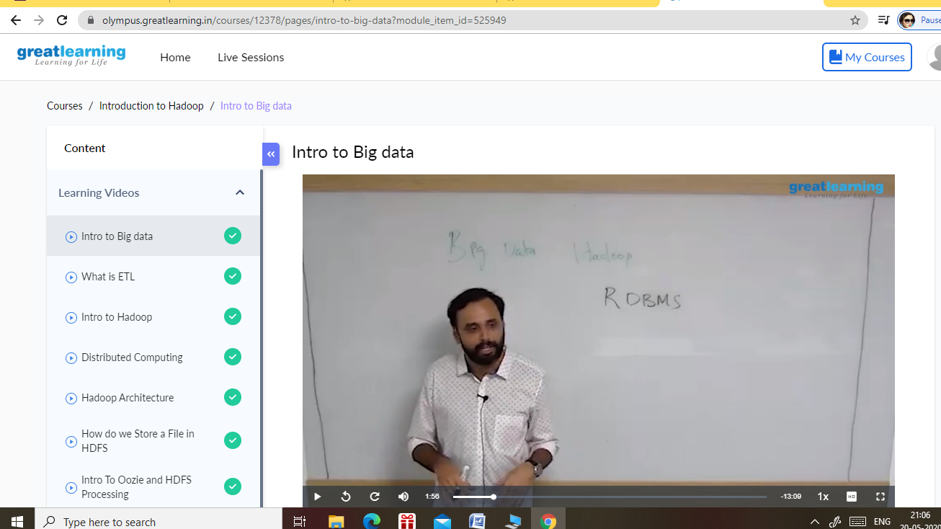

SNAPSHOT OF THE CERTIFICATION COURSE, INTRODUCTION TO HADOOP.

1. TOPICS COVERED OF CERTIFICATION COURSE:-
2. INTRO TO BIG DATA
3. WHAT IS ETL
4. INTRO TO HADOOP
5. DISTRIBUTED COMPUTING
6. HADOOP ARCHITECTURE
7. HOW DO WE STORE A FILE IN HDFS
8. INTRO TO OOZIE AND HDFS PROCESSING

Coding Challenges Details: (Attach the snapshot and briefly write the report for the same)

PROBLEM STATEMENT:-

1.Using methods charAt() & length() of String class, write a program to print the  
frequency of each character in a string.  
“Hello friend”

Output should be  
-: 1  
d: 1  
e: 2  
f: 1

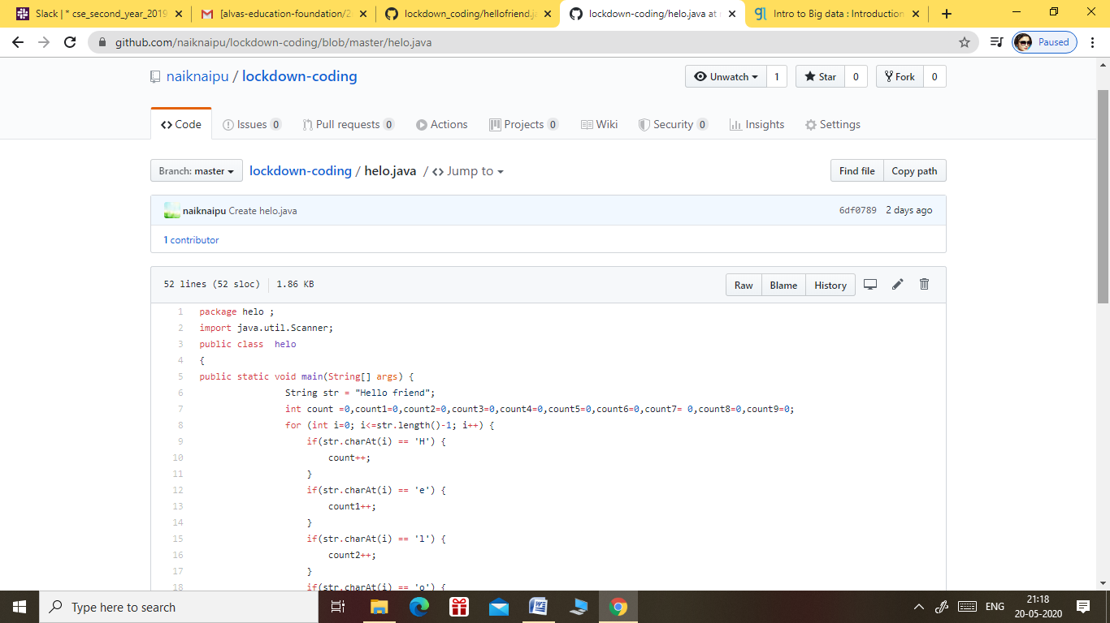

GITHUB REPOSITORY LINK:-

<https://github.com/naipunya-naik/lockdown-coding/blob/master/JAVA%20CODING/npr_31-05-2020.java>